|  |  |
| --- | --- |
| EGC_Black | Student Name \_\_\_\_\_\_\_\_\_\_\_\_\_\_\_\_\_\_\_\_\_\_\_  **Eastern Goldfields College**  Mathematics Methods Unit 1 2017  **Test 111– Calculator Free Section** |

|  |  |
| --- | --- |
| Working Time: 40 minutes | Total Marks: 46 marks |

**Calculators and notes are NOT permitted in this section.**

***Answer all of the following questions. Show all working to obtain full marks.***

Question 1 (5 marks – 1, 2, 2)

Solve the following equations for .

(a) .

(b) .

(c) .

Question 2 (13 marks – 1, 1, 1, 1, 3, 3, 3)

(a)

(i) What are the coordinates of the -intercept of the graph of ?

(ii) State the number of roots of the graph of .

(iii) What are the coordinates of the turning point of the graph of?

(iv) What is the equation of the line of symmetry of the graph of ?

(b) Determine the equation of the quadratic function that passes through the point (0, -9) and has a turning point at (-2, 3).

(c) Solve the following equations.

(i) .

(ii) .

Question 3 (9 marks – 1, 1, 1, 3, 3)

(a) A line has equation . Determine

(i) the gradient of the line.

(ii) the coordinates of the -intercept of the line.

(iii) the coordinates of the -intercept of the line.

(b) Determine the equation of the line that is perpendicular to the line in (a) and that passes through the point (6, -1), giving your answer in the form , where  are integers.

(c) The mid-point of  and  is . Determine the coordinates of the midpoint of  and .

Question 4 (3 marks – 2, 1)

1. Explain with reference to the discriminant in the quadratic formula, why the function

has only one root.

1. From your answer in part(a), what can you say about the turning point of this function?

Question 5 (4 marks – 1, 1, 2)

Use the unit circle below to answer the questions that follow. Give your answers to an appropriate degree of accuracy.

1. Determine the value of sin 80°
2. Determine the value of cos 130°
3. Solve for x: sin x =0.3 for 0° ≤ x ≤ 360°

**Question 6 (4 marks)**

The triangle shown below has an area of 36 cm2, determine the value of x.

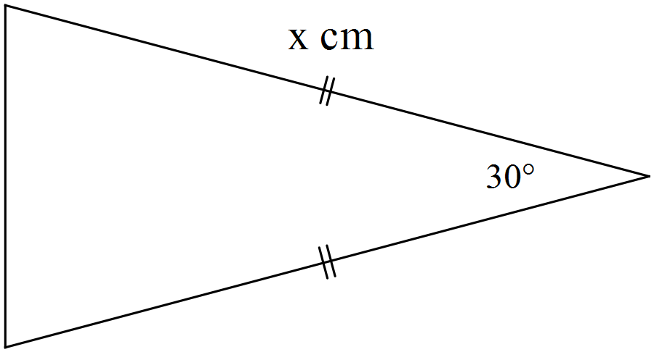

**Question 7 (2 marks)**

Determine the equation of the linear function shown below. All values should be expressed in exact form.

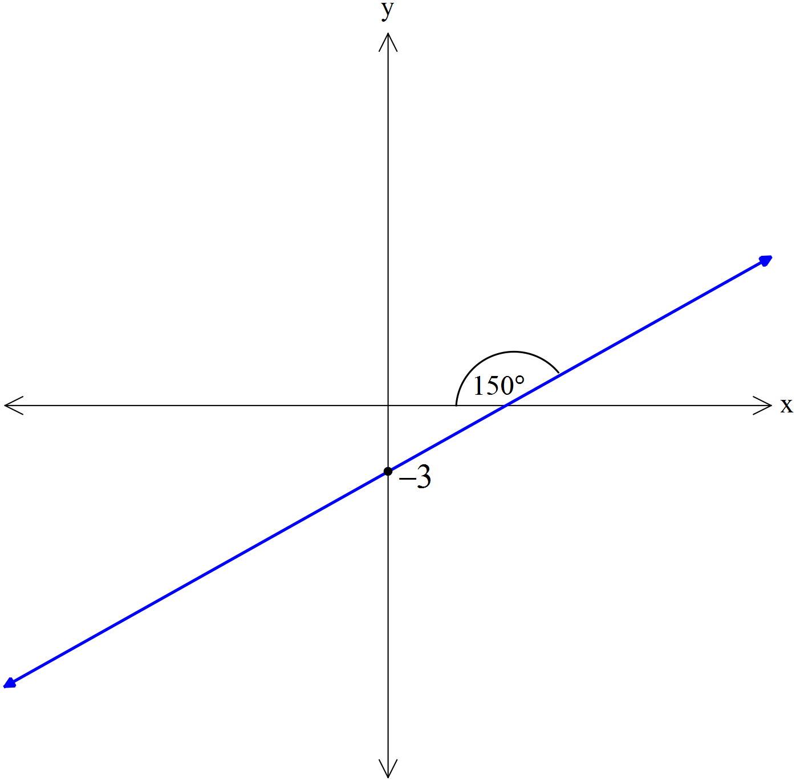

**Question 8 (2 marks – 1, 1)**

State their exact value:

(a) cos 150° (b) sin 135°

**Question 9 (4 marks)**

Find the exact value of expressed with a rational denominator.

|  |  |
| --- | --- |
| EGC_Black | Student Name \_\_\_\_\_\_\_\_\_\_\_\_\_\_\_\_\_\_\_\_\_\_\_  **Eastern Goldfields College**  Mathematics Methods Unit 1 2017  **Test 111– Calculator Assumed Section** |

|  |  |
| --- | --- |
| Working Time: 25 minutes | Total Marks: 22 marks |

**Question 10 (9 marks – 2, 2, 5)**

(a) Consider the triangle below. The lengths of all sides of the triangle are given.



(i) Determine the size of the angle BAC

(ii) Determine the area of the triangle ABC

(b) A second triangle, *PQR*, has *PR = 8*, *QR = 5* and 

Determine the length of *PQ* and the size of the angle 

**Question 11 (6 marks – 2, 2, 2)**

A ramp walkway is to be built over a ravine. A river runs through the ravine. The walkway is to be attached to a supporting cable with guy wires as show in the cross sectional diagram below. Both the ramp walkway and the supporting cable are in the shape of a quadratic function. The x−axis represents the water level, the left hand edge of the ravine aligns with the y−axis and the right hand edge of the ravine is also shown in the diagram. The guy wires are evenly spaced along the ramp.

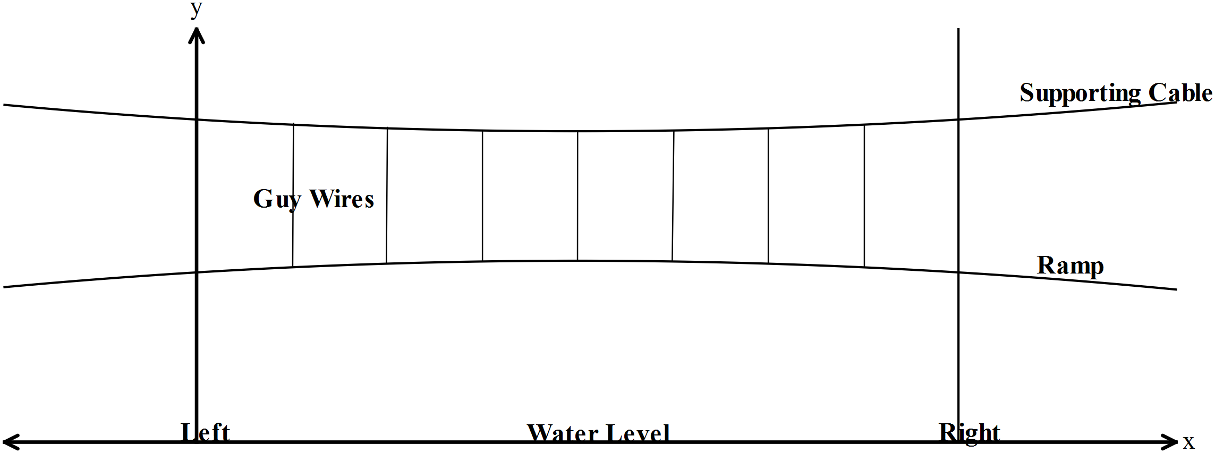

The equation of the *ramp walkway* is given by the function ***y = −0.001x2 + 0.062x + 18.04***

The equation of the *supporting cable* is given by the function ***y = 0.003x2 – 0.186x + 25.18***

(a) Find the maximum height of the ramp walkway above the water level.

(b) Determine the width of the ravine.

(c) Find the distances from the left end that the supporting cable is exactly 24 metres above the water?

**Question 12 (3 marks – 2, 1)**

The owner of a shop that sells computers calculates that his total weekly profit is given by the rule:

Total profit in dollars =,

where  is the profit per computer sold,  is the number of computers sold in the week and  is the fixed weekly cost of running the shop.

If he sells ten computers in a week his total profit is $360.

If he only sells five computers in the week he makes a loss of $190.

1. Calculate  and .
2. What is the least number of computers he can sell and still make a profit?

**Question 13 (4 marks – 2, 2)**

Three consecutive positive integers are such that if you add the square of the smallest integer to the product of the other two integers the answer is 154. Determine the three integers.

(Note: An example of consecutive integers are 34,35,36 or -207, -206, -205)

1. Write an equation to describe this situation. Hint: Let the integers be x, x+ 1 and x +2.
2. Find the three integers.